## A REPORT ON

**WE SAFE- A WOMEN SAFETY DEVICE BY USING IOT**

**DIPLOMA IN ENGINEERING (ELECTRONICS & TELECOMMUNICATION ENGINEERING)**

## SUBMITTED BY

|  |  |
| --- | --- |
| **HARSHALI BORHADE** | **197012** |
| **SRUSHTI RASKAR** | **197009** |
| **NANDINI DAMARE** | **197044** |

**UNDER THE GUIDANCE OF**

PROF. (DR.) A.S. CHANDAK

PROF. AJAY BORKAR



**DEPARTMENT OF ELECTRONICS**

**AND TELECOMMUNICATION ENGINEERING**

## MODERN EDUCATION SOCIETY’s CUSROW WADIA INSTITUTE OF TECHNOLOGY

**19, LATE PRIN V.K. JOAG PATH, WADIA COLLEGE CAMPUS, PUNE 411001**

**CERTIFICATE**



**This is to certify that the project entitled “WE SAFE- A WOMEN SAFETY DEVICE BY USING IOT”**

**Has been successfully completed by the students**

|  |  |
| --- | --- |
| **Harshali Borhade** | **197012** |
| **Srushti Raskar** | **197009** |
| **Nandini Damare** | **197044** |

**For the partial fulfillment of Diploma in Electronics and Telecommunication Engineering during the academic year 2021- 2022. This work is carried out by them under our supervision and guidance.**

**Project Guide**

**Prof. A.Y. Borkar Prof. (Dr.) A.S. Chandak**

**(Project Coordinator) (Head E & TC Department)**

# ACNOWLEDGEMENT

It gives us great pleasure in presenting the preliminary project report on ‘**WE SAFE- A WOMEN SAFETY DEVICE USING IOT**’.

I would like to take this opportunity to thank my internal guide **Prof. AJAY BORKAR** for giving me all the help and guidance, I needed. I am really grateful to them for their kind support. Their valuable suggestions were very helpful.

I am also grateful **to Prof. ASHOK CHANDAK**, Head of Electronics and Telecommunication Engineering Department, **Modern Education Society’s Cusrow Wadia Institute of Technology** for his indispensable support, suggestions.

In the end our special thanks to **Prof. SHUBHANGEE VERMA** for providing various resources for our Project.

Harshali Borhade **197012**

Srushti Raskar **197009**

Nandini Damare **197044**

(**Third year Diploma in E & TC Engg.**)

# ABSTRACT

Women safety has been a big concern and it has been the most important duty of every person. There is no chance of the welfare of the world unless the condition of the women is improved. Since the ancient time, women are given most respected place in the society but every day and every minute some women of all walks of life (women, girls and babies) are getting harassed, molested, assaulted and violated at various places all over the world. It is estimated that 35% of the women have experienced physical and/or sexual violence at some point in their lives. This paper includes various ideologies and methodologies of numerous authors who have reviewed multiple applications and devices using present technologies and processors and they have also upgraded these with certain requirements in order to decrease violence against women. Also a small measure of improvement proposed in this paper, adds to the better performance of these devices and lead to better women safety.

This Project presents a women safety device using GPS, BP sensor, Temperature sensor, accelerometer,Buzzer and IP Webcam APP . In this system a microcontroller is interfaced with GPS, Temperature sensor, accelerometer and buzzer . This detection and messaging system is composed of a GPS and Microcontroller. GPS Receiver gets the location information from satellites in the form of latitude and longitude.

GPS module is connected to arduino UNO, this Module collects the information and sends data to Arduino Uno. Buzzer is an audio signal device, which is used to buzz sound whenever it is needed. At last, a sms(short message service) or mail is sends to a phone. When a woman is in danger and in need of self-defense then by checking the temperature device sent the message to the concern person with the image of the location where the incident happened on the gmail.

# TABLE OF CONTENTS

|  |  |  |  |
| --- | --- | --- | --- |
| **Chapter** | | **Title of Chapter** | **Page no.** |
| **01** | | **Introduction** | 7 |
|  | 1.1 | Introduction | 7 |
|  | 1.2 | Overview | 8 |
|  | 1.3 | Problem Definition | 8 |
| **02** | | **Literature Survey** | 9 |
| **03** | | **Working and Methodology** | 11 |
| 3.1 | | Components | 11 |
|  | 3.1.1 | ATMEGA328 Microcontroller Description | 11 |
|  | 3.1.2 | Arduino Uno Board Description | 17 |
|  | 3.1.3 | Sunrom BP Sensor | 19 |
|  | 3.1.4 | GPS Sensor | 23 |
|  | 3.1.5 | LM35 (Temperature sensor) | 26 |
|  | 3.1.6 | Accelerometer | 29 |
|  | 3.1.7 | Buzzer | 31 |
|  | 3.1.8 | CP2102 USB 2.0 to TTL UART serial converter module | 32 |
|  | 3.2 | Architecture of Proposed system | 34 |
|  | 3.3 | Working | 35 |
|  | 3.5 | Special Features | 37 |
| **04** | | **Code Source & Result** | 38 |
| **05** | | **Conclusion** | 43 |
|  | 5.1 | Conclusion | 43 |
|  | 5.2 | Future Work | 43 |
|  | 5.3 | Applications | 43 |
|  | 5.4 | Advantages and Disadvantages | 44 |
| **REFERENCES** | | | 45 |

**LIST OF FIGURES**

**Figure No 1.** Pin configuration of ATMEGA328

**Figure No 2.** Arduino Board UNO

**Figure No 3.** Sunrom BP sensor

**Figure No 4.** MCU TTL UART interfacing

**Figure No 5.** Output of BP sensor

**Figure No 6**. BP checking procedure

**Figure No 7.** GPS sensor (GY-GPS6MV2)

**Figure No 8.** Schematic of GPS sensor

**Figure No 9.** LM35

**Figure No 10.** LM35 Pins

**Figure No 11**. Application Setup of LM35

**Figure No 12.** Accelerometer

**Figure No 13.** Buzzer

**Figure No 14.** CP2102 USB 2.0 to TTL UART serial converter module

**Figure No 15.** Architecture of proposed system.

## LIST OF TABLE

## 

## Table no 1. Pin description table of ATMEGA328

# INTRODUCTION

## INTRODUCTION

The Internet Of Things is the network of physical devices, home appliances and other items embedded with electronics, software, sensors, actuators, and network connectivity which enables these objects to connect and exchange data. Health is a dynamic process which needs to be continuously monitored. In our system we are measuring patient’s parameters (Temperature, blood pressure, Camera and GPS etc.) different available sensors data.“Things” in the IOT sense can refer to a wide variety of devices. Women safety has always been an issue even in these modern times with so much advancement in technology. Women are not safe anywhere and are most vulnerable when traveling alone into lonely roads and deserted places.

Women safety is a very important issue due to rising crimes against women these days. To help resolve this issue, a GPS based women safety system is proposed that has dual security feature. This device consists of a system that ensures dual alerts in case a woman is harassed or she thinks she is in trouble.

## OVERVIEW

This Project presents a women safety device using GPS, BP sensor, Temperature sensor, accelerometer,Buzzer and IP Webcam APP . In this system a microcontroller is interfaced with GPS, Temperature sensor, accelerometer and buzzer . This detection and messaging system is composed of a GPS and Microcontroller. GPS Receiver gets the location information from satellites in the form of latitude and longitude.

GPS module is connected to arduino UNO, this Module collects the information and sends data to Arduino Uno. Buzzer is an audio signal device, which is used to buzz sound whenever it is needed. At last, a sms(short message service) or mail is sends to a phone. When a woman is in danger and in need of self-defense then by checking the temperature device sent the message to the concern person with the image of the location where the incident happened on the gmail.

## PROBLEM DEFINITION

In this research we design and develop a system for Women Safety Device using IoT and soft computing techniques. This work also demonstrates to send emergency message to nearest station when misshaping events occurs.

# LITERATURE SURVEY

|  |  |  |  |
| --- | --- | --- | --- |
| **Sr no.** | **Author and Title of Paper** | **Publication and year** | **Description** |
| 1 | Ghosh, Prottasha, et al. "Smart Security Device for Women Based on IoT Using Raspberry Pi." | IEEE 2021 | A new Internet-of-Things-based evidence-gathering gadget to safeguard the safety and security of women This system combines a Raspberry Pi, buzzer, and camera, as well as flex sensor, GSM, and GPS modules. Women may simply and comfortably use this little gadget with their underwear. |
| 2 | Hyndavi, V., N. Sai Nikhita, and S. Rakesh. "Smart wearable device for women safety using IoT." | IEEE 2020 | A smart gadget for women's protection is presented that automates the emergency alarm system by utilising pressure, pulse-rate, and temperature sensors to automatically identify a prospective atrocity via outlier detection. |
| 3 | Kabir, AZM Tahmidul, and Tasnuva Tasneem. "Safety Solution for Women Using Smart Band and CWS App." | IEEE 2020 | Women's movement may be made safer with the help of an IoT gadget and an Android app. By hitting the device's emergency button, women may get immediate and comprehensive safety assistance. In the event of an issue, this gadget can monitor the user's position in real time and relay it to a local police station and volunteer. This gadget may also provide the user with the location of the closest safe zone. Arduino nano, GPS, GSM, Bluetooth, and other components make up the gadget. |
| 4 | Akram, Wasim, Mohit Jain, and C. Sweetlin Hemalatha. "Design of a smart safety device for women using IoT." | Elsevier (2019) | an IoT-based safety gadget that depends on fingerprint-based connection to the device to provide protection to women while also notifying local individuals and authorities when a woman is not secure. Fingerprint verification detects a dangerous condition for a minute, then immediately alerts surrounding individuals and authorities if the gadget detects no signal. Furthermore, a shockwave generator has been built for first-hand safety so that ladies may fight the attacker. The suggested design also includes additional functionality such as sending group messages and audio recording. |
| 5 | Sunehra, Dhiraj, et al. "Raspberry Pi Based Smart Wearable Device for Women Safety using GPS and GSM Technology." | IEEE 2020 | an IoT-based safety gadget that depends on fingerprint-based connection to the device to provide protection to women while also notifying local individuals and authorities when a woman is not secure. Fingerprint verification detects a dangerous condition for a minute, then immediately alerts surrounding individuals and authorities if the gadget detects no signal. Furthermore, a shockwave generator has been built for first-hand safety so that ladies may fight the attacker. The suggested design also includes additional functionality such as sending group messages and audio recording. |

# WORKING AND METHODOLOGY

* 1. **COMPONENTS**

## ATMEGA328 MICROCONTROLLER DESCRIPTION

## The Atmel AVR® core combines a rich instruction set with 32 general purpose working registers. All the 32 registers are directly connected to the Arithmetic Logic Unit (ALU), allowing two independent registers to be accessed in a single instruction executed in one clock cycle. The resulting architecture is more code efficient while achieving throughputs up to ten times faster than conventional CISC microcontrollers. The ATmega328/P provides the following features: 32Kbytes of In-System Programmable Flash with Read-While-Write capabilities, 1Kbytes EEPROM, 2Kbytes SRAM, 23 general purpose I/O lines, 32 general purpose working registers, Real Time Counter (RTC), three flexible Timer/Counters with compare modes and PWM, 1 serial programmable USARTs , 1 byte-oriented 2-wire Serial Interface (I2C), a 6- channel 10- bit ADC (8 channels in TQFP and QFN/MLF packages) , a programmable Watchdog Timer with internal Oscillator, an SPI serial port, and six software selectable power saving modes. This allows very fast start-up combined with low power consumption. In Extended Standby mode, both the main oscillator and the asynchronous timer continue to run. Atmel offers the QTouch® library for embedding capacitive touch buttons, sliders and wheels functionality into AVR microcontrollers. The patented charge-transfer signal acquisition offers robust sensing and includes fully debounced reporting of touch keys and includes Adjacent Key Suppression® (AKS™) technology for unambiguous detection of key events. The easy-to-use QTouch Suite toolchain allows you to explore, develop and debug your own touch applications. The device is manufactured using Atmel’s high density non-volatile memory technology. The On-chip ISP Flash allows the program memory to be reprogrammed In-System through an SPI serial interface, by a conventional nonvolatile memory programmer, or by an On-chip Boot program running on the AVR core.

## The ATmega328/P is supported with a full suite of program and system development tools including: C Compilers, Macro Assemblers, Program Debugger/Simulators, In-Circuit Emulators, and Evaluation kits.

## FEATURES OF A ATMEG

## • 28-pin AVR Microcontroller

## • Flash Program Memory: 32 kbytes

## • EEPROM Data Memory: 1 kbytes

## • SRAM Data Memory: 2 kbytes

## • I/O Pins: 23 • Timers: Two 8-bit / One 16-bit

## • A/D Converter: 10-bit Six Channel

## • PWM: Six Channels

## • RTC: Yes with Separate Oscillator

## • MSSP: SPI and I²C Master and Slave Support

## • USART: Yes

## • External Oscillator: up to 20MHz

## ADVANTAGES/ IMPROVEMENTS IN ATMEG328

## 1. Still runs on 5 V, so legacy 5 V stuff interfaces cleaner

## 2. Even though it's 5 V capable, newer parts can run to 1.8 V. This wide range is very rare.

## 3. Nice instruction set, very good instruction throughput compared to other processors (HCS08, PIC12/16/18).

## 4. High quality GCC port (no proprietary crappy compilers!)

## 5. "PA" variants have good sleep mode capabilities, in micro-amperes.

## 6. Well rounded peripheral set

## 7. QTouch capability

## PIN DIAGRAM OF ATMEGA328

## 

## Fig no.1 Pin Configuration of ATMEGA328

## PIN DESCRIPTIONS TABLE

## 

## Table no. 1 Pin Descriptions table of ATMEGA328

## PIN EXPLANATION

## VCC Digital supply voltage.

## GND Ground.

## Port B (PB[7:0]) XTAL1/XTAL2/TOSC1/TOSC2 Port B is an 8-bit bi-directional I/O port with internal pull-up resistors (selected for each bit). The Port B output buffers have symmetrical drive characteristics with both high sink and source capability. As inputs, Port B pins that are externally pulled low will source current if the pull-up resistors are activated. The Port B pins are tri-stated when a reset condition becomes active, even if the clock is not running. Depending on the clock selection fuse settings, PB6 can be used as input to the inverting Oscillator amplifier and input to the internal clock operating circuit. Depending on the clock selection fuse settings, PB7 can be used as output from the inverting Oscillator amplifier. If the Internal Calibrated RC Oscillator is used as chip clock source, PB[7:6] is used as TOSC[2:1] input for the Asynchronous Timer/Counter2 if the AS2 bit in ASSR is set.

## Port B (PB[7:0]) XTAL1/XTAL2/TOSC1/TOSC2 Port B is an 8-bit bi-directional I/O port with internal pull-up resistors (selected for each bit). The Port B output buffers have symmetrical drive characteristics with both high sink and source capability. As inputs, Port B pins that are externally pulled low will source current if the pull-up resistors are activated. The Port B pins are tri-stated when a reset condition becomes active, even if the clock is not running. Depending on the clock selection fuse settings, PB6 can be used as input to the inverting Oscillator amplifier and input to the internal clock operating circuit. Depending on the clock selection fuse settings, PB7 can be used as output from the inverting Oscillator amplifier. If the Internal Calibrated RC Oscillator is used as chip clock source, PB[7:6] is used as TOSC[2:1] input for the Asynchronous Timer/Counter2 if the AS2 bit in ASSR is set.

## Port B (PB[7:0]) XTAL1/XTAL2/TOSC1/TOSC2 Port B is an 8-bit bi-directional I/O port with internal pull-up resistors (selected for each bit). The Port B output buffers have symmetrical drive characteristics with both high sink and source capability. As inputs, Port B pins that are externally pulled low will source current if the pull-up resistors are activated. The Port B pins are tri-stated when a reset condition becomes active, even if the clock is not running. Depending on the clock selection fuse settings, PB6 can be used as input to the inverting Oscillator amplifier and input to the internal clock operating circuit. Depending on the clock selection fuse settings, PB7 can be used as output from the inverting Oscillator amplifier. If the Internal Calibrated RC Oscillator is used as chip clock source, PB[7:6] is used as TOSC[2:1] input for the Asynchronous Timer/Counter2 if the AS2 bit in ASSR is set.

## Port C (PC[5:0]) Port C is a 7-bit bi-directional I/O port with internal pull-up resistors (selected for each bit). The PC[5:0] output buffers have symmetrical drive characteristics with both high sink and source capability. As inputs, Port C pins that are externally pulled low will source current if the pull-up resistors are activated. The Port C pins are tri-stated when a reset condition becomes active, even if the clock is not running.

## PC6/RESET If the RSTDISBL Fuse is programmed, PC6 is used as an I/O pin. Note that the electrical characteristics of PC6 differ from those of the other pins of Port C. If the RSTDISBL Fuse is unprogrammed, PC6 is used as a Reset input. A low level on this pin for longer than the minimum pulse length will generate a Reset, even if the clock is not running. Shorter pulses are not guaranteed to generate a Reset. The various special features of Port C are elaborated in the Alternate Functions of Port C section.

## Port D (PD[7:0]) Port D is an 8-bit bi-directional I/O port with internal pull-up resistors (selected for each bit). The Port D output buffers have symmetrical drive characteristics with both high sink and source capability. As inputs Port D pins that are externally pulled low will source current if the pull-up resistors are activated. The Port D pins are tri-stated when a reset condition becomes active, even if the clock is not running.

## AVCC AVCC is the supply voltage pin for the A/D Converter, PC[3:0], and PE[3:2]. It should be externally connected to VCC, even if the ADC is not used. If the ADC is used, it should be connected to VCC through a low-pass filter. Note that PC[6:4] use digital supply voltage, VCC. 4.5.8. AREF AREF is the analog reference pin for the A/D Converter. 4.1.5.9. ADC[7:6] (TQFP and VFQFN Package Only) In the TQFP and VFQFN package, ADC[7:6] serve as analog inputs to the A/D converter. These pins are powered from the analog supply and serve as 10-bit ADC channels.

## 3.1.2 ARDUINO UNO BOARD DESCRIPTION

We will learn about the different components on the Arduino board. We will study the Arduino UNO board because it is the most popular board in the Arduino board family. In addition, it is the best board to get started with electronics and coding. Some boards look a bit different from the one given below, but most Arduinos have majority of these components in common.

## 

**Fig no.2 Arduino UNO Board**

1. **Power USB**

Arduino board can be powered by using the USB cable from wer computer. All we need to do is connect the USB cable to the USB connection (1).

1. **Power (Barrel Jack)**

Arduino boards can be powered directly from the AC mains power supply by connecting it to the Barrel Jack (2).

1. **Voltage Regulator**

The function of the voltage regulator is to control the voltage given to the Arduino board and stabilize the DC voltages used by the processor and other elements.

1. **Crystal Oscillator**

The crystal oscillator helps Arduino in dealing with time issues. How does Arduino calculate time? The answer is, by using the crystal oscillator. The number printed on top of the Arduino crystal is 16.000H9H. It tells us that the frequency is 16,000,000 Hertz or 16 MHz.

1. **Arduino Reset**

We can reset wer Arduino board, i.e., start wer program from the beginning. We can reset the UNO board in two ways. First, by using the reset button (17) on the board. Second, we can connect an external reset button to the Arduino pin labelled RESET (5).

1. **Pins (3.3, 5, GND, Vin)**

• 3.3V (6) − Supply 3.3 output volt

• 5V (7) − Supply 5 output volt

• Most of the components used with Arduino board works fine with 3.3 volt and 5 volt.

• GND (8) (Ground) − There are several GND pins on the Arduino, any of which can be used to ground were circuit.

• Vin (9) − This pin also can be used to power the Arduino board from an external power source, like AC mains power supply. 4.2.7 Analog pins o The Arduino UNO board has five analog input pins A0 through A5. These pins can read the signal from an analog sensor like the humidity sensor or temperature sensor and convert it into a digital value that can be read by the microprocessor.

1. **Analog pins**

The Arduino UNO board has five analog input pins A0 through A5. These pins can read the signal from an analog sensor like the humidity sensor or temperature sensor and convert it into a digital value that can be read by the microprocessor.

**3.1.3 SUNROM BP SENSOR**

Blood Pressure & Pulse reading are shown on display with serial out for external projects of embedded circuit processing and display. Shows Systolic, Diastolic and Pulse Readings. Compact design fits over your wrist like a watch. Easy to use wrist style eliminates pumping.

* **Features**
* Intelligent automatic compression and decompression
* Easy to operate, switching button to start measuring
* 60 store groups memory measurements
* Can read single or all measures
* 3 minutes automatic power saving device
* Intelligent device debugging, automatic power to detect
* Local tests for : wrist circumference as 135-195mm
* Large-scale digital liquid crystal display screen, Easy to Read Dsplay
* Fully Automatic, Clinical Accuracy, High-accuracy
* Power by External +5V DC
* Serial output data for external circuit processing or display.
* **Specification**
* Working Voltage: +5V, 200mA regulated
* Output Format :Serial Data at 9600 baud rate(8 bits data, No parity, 1 stop bits). Outputs three parameters in ASCII.
* Sensing unit wire length is 2 meters
* **Sensor Pinouts**
* TX-OUT = Transmit output. Output serial data of 3V logic level, Usually connected to RXD pin of microcontrollers/RS232/USB-UART.
* +5V = Regulated 5V supply input.
* GND = Board Common Ground

### Blood Pressure Basics

Blood pressure is the pressure of the blood in the arteries as it is pumped around the body by the heart. When your heart beats, it contracts and pushes blood through the arteries to the rest of your body. This force creates pressure on the arteries. Blood pressure is recorded as two numbers— the systolic pressure (as the heart beats) over the diastolic pressure (as the heart relaxes between beats). The unit which measures this is called Sphygmomanometer.

Monitoring blood pressure at home is important for many people, especially if you have high blood pressure. Blood pressure does not stay the same all the time. It changes to meet your body’s needs. It is affected by various factors including body position, breathing or emotional state, exercise and sleep. It is best to measure blood pressure when you are relaxed and sitting or lying down.

1. **Classification of blood pressure for adults (18 years and older)**

|  |  |  |
| --- | --- | --- |
|  | **Systolic (mm Hg)** | **Diastolic (mm Hg)** |
| **Hypotension** | < 90 | < 60 |
| **Desired** | 90–119 | 60–79 |
| **Prehypertension** | 120–139 | 80–89 |
| **Stage 1 Hypertension** | 140–159 | 90–99 |
| **Stage 2 Hypertension** | 160–179 | 100–109 |
| **Hypertensive Crisis** | ≥ 180 | ≥ 110 |

High blood pressure (hypertension) can lead to serious problems like heart attack, stroke or kidney disease. High blood pressure usually does not have any symptoms, so you need to have your blood pressure checked regularly.

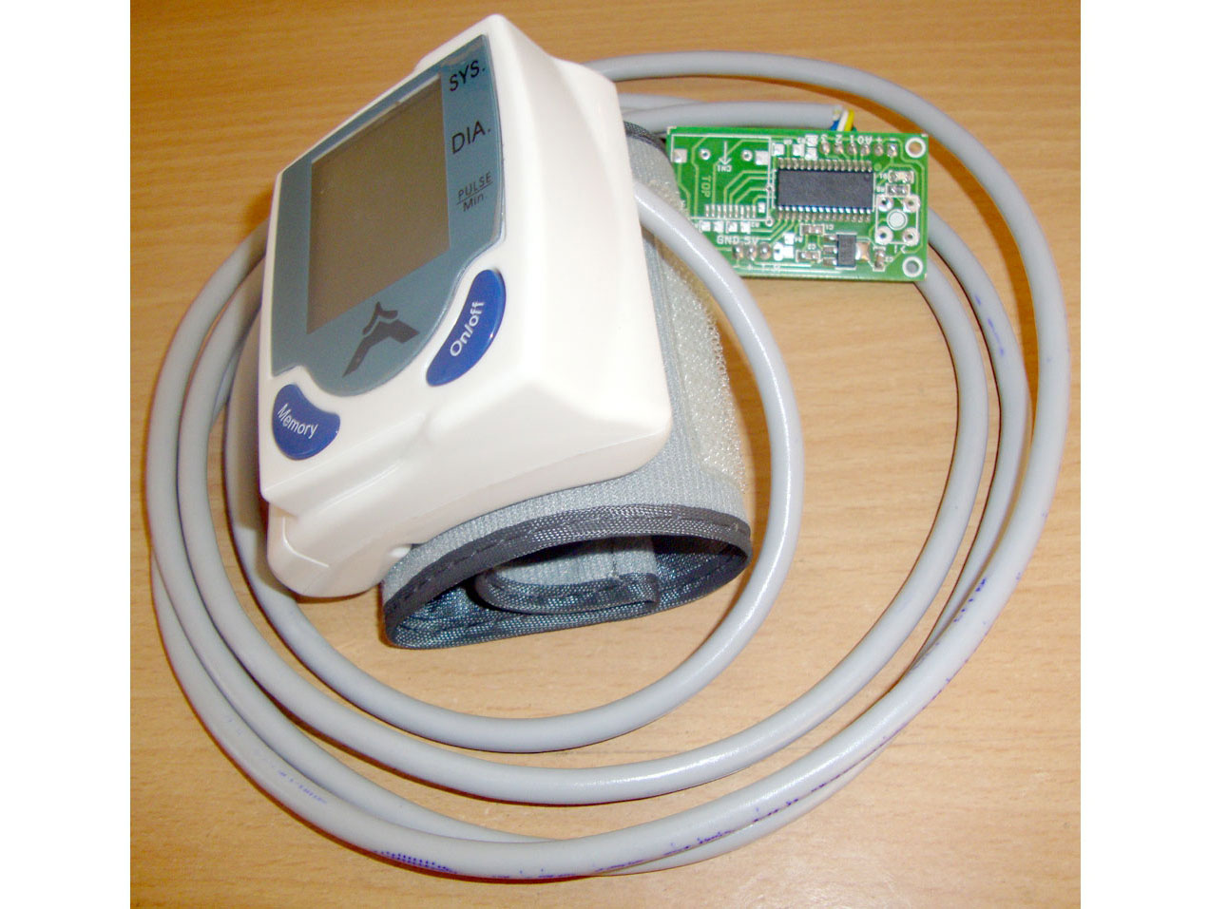

**Fig no.3 Sunrom BP sensor**

### MCU Interfacing

It’s very easy to interface with microcontroller having UART. Configure your microcontroller to communicate at 9600 baud rate. Start reading incoming ASCII data. You can use this ASCII data to display on seven segment, LCD or convert to integer and do calculations as per project requirement. If you need integer values, you convert ASCII packet to Integer. In our sample code below, we have converted this ASCII value to interger.

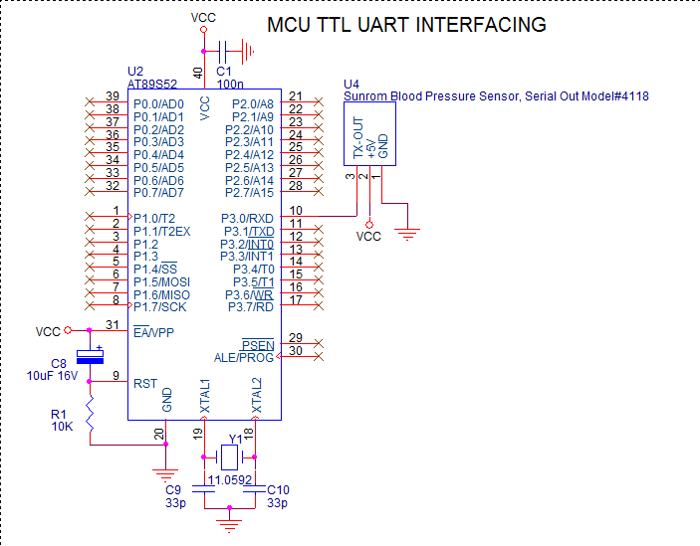

**Fig no.4 MCU TTL UART interfacing**

1. **Output of SUNROM BP SENSOR/ Result:**

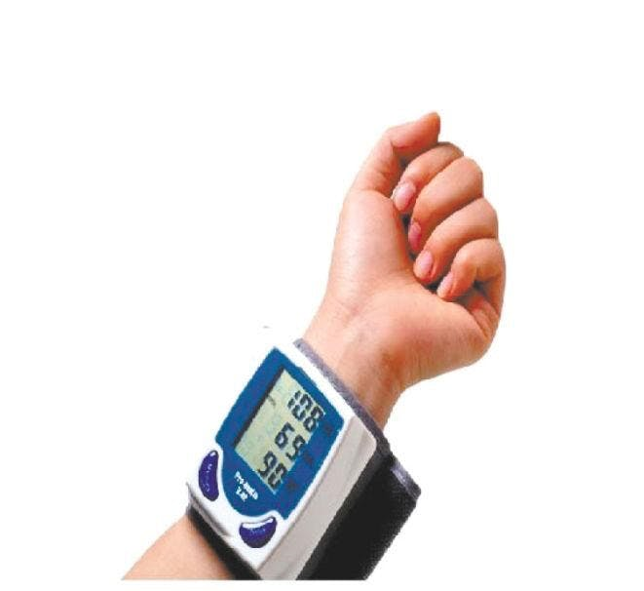

**Fig no.5 Output of BP sensor**

We get three values as OUTPUT on SUNROM BP SENSOR:

* 1. Systolic
  2. Diastolic
  3. Pulse per minute.

1. **BP checking procedure:**

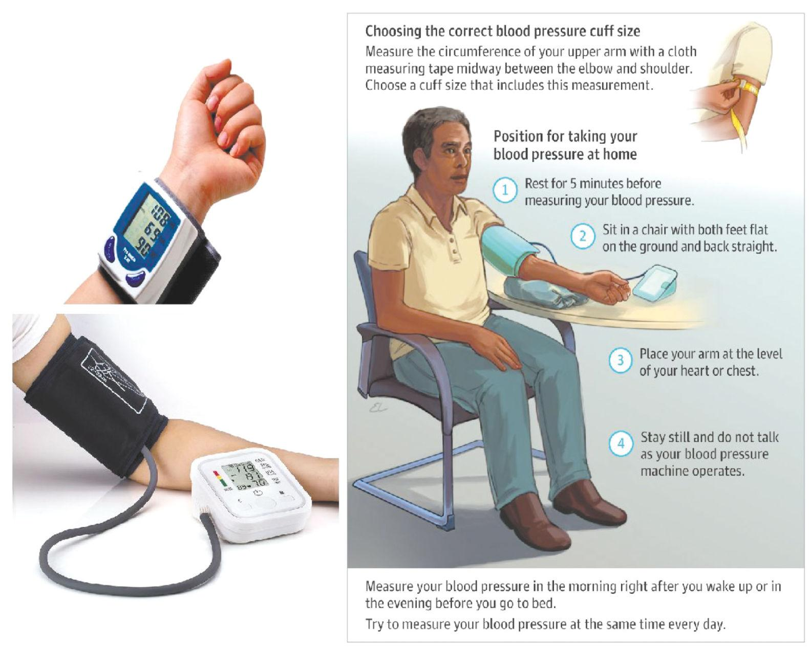

**Fig no.6 BP checking Procedure**

**3.1.4 GPS SENSOR**

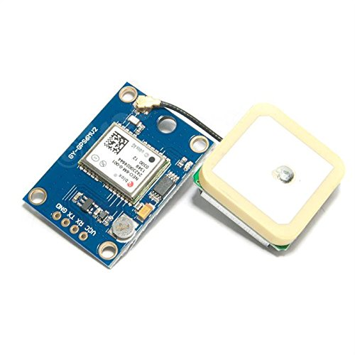

**Fig no. 7 GPS sensor (GY-GPS6MV2)**

GY-NEO6MV2 board features the u-blox NEO-6M GPS module with antenna and built-in EEPROM. This is compatible with various flight controller boards designed to work with a GPS module.

* **Technical Specifications**

• Power Supply Range: 3 V to 5 V

• Model: GY-GPS6MV2

• Ceramic antenna

• EEPROM for saving the configuration data when powered off

• Backup battery

• LED signal indicator

• Mounting Hole Diameter: 3 mm

• Default Baud Rate: 9600 bps

• Module size 23mm * 30mm

• Antenna size 12 * 12mm

• Cable:20mm

* **Features**

• Use XM37-1612 module, MTK Platform, with high-gain active antenna

• TTL level, compatible with 3.3V/5V system

• The default baud rate: 9600

• With rechargeable backup battery, can save the ephemeris data when it power down, and make

the warm start.

• Suitable for RC quad copter, navigator.

* **Pin out:**

VCC: Connect 3.3V/5V

GND: Connect GND

TXD: Connect MCU.RX

RXD: Connect MCU.TX

* **Schematic:**

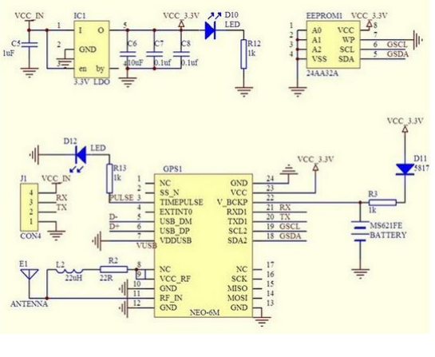

**Fig no.8 Schematic of GPS sensor**

* + 1. **LM35 (TEMPERATURE SENSOR)**

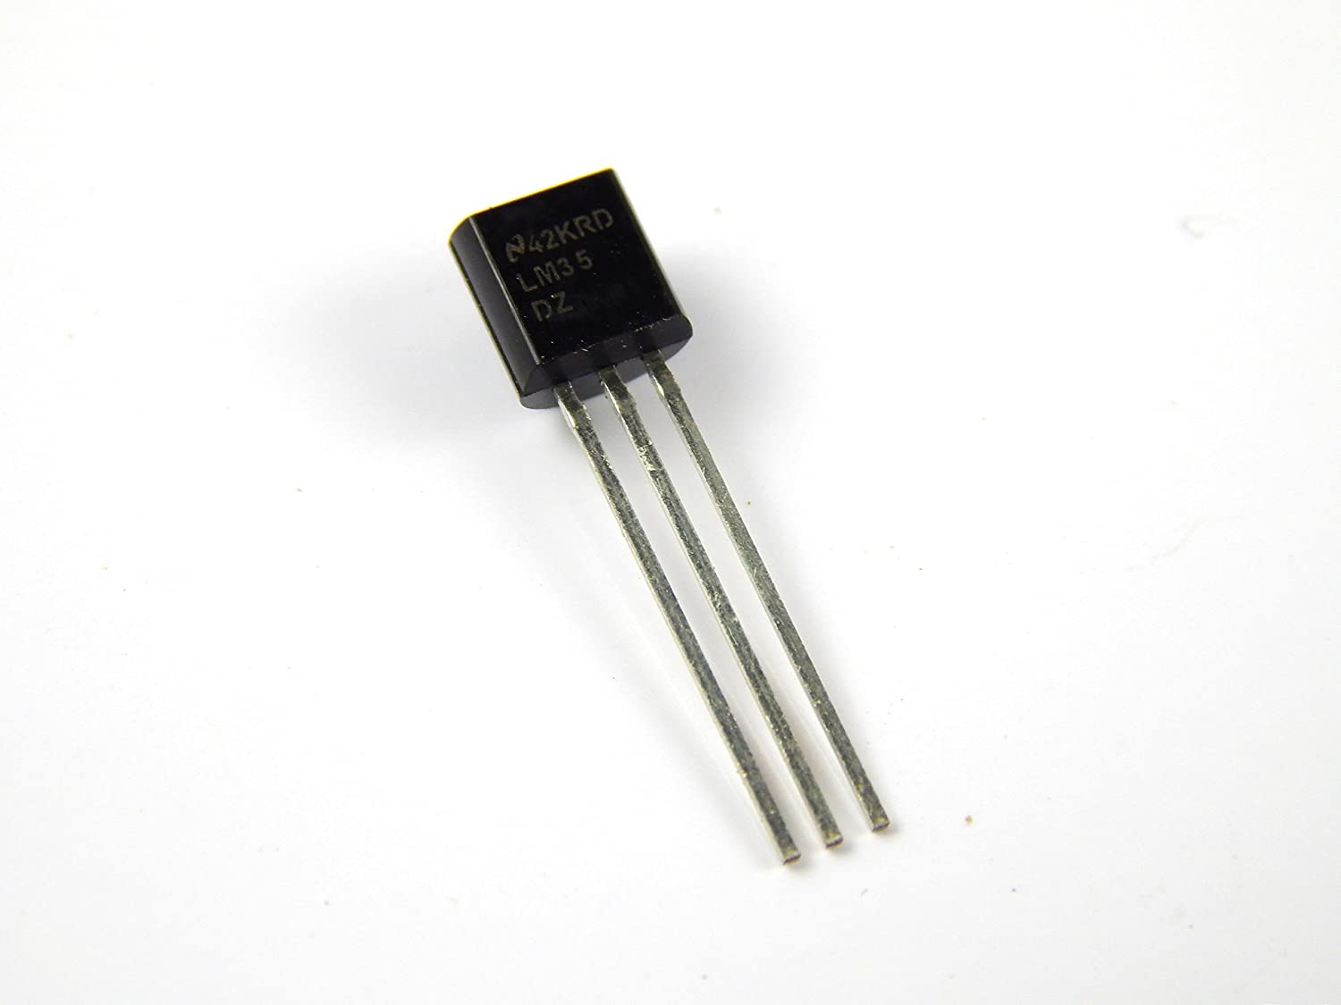

**Fig no.9 LM35**

1. LM35 is a temperature measuring device having an analog output voltage proportional to the temperature.
2. It provides output voltage in Centigrade (Celsius).
3. It does not require any external calibration circuitry. The sensitivity of LM35 is 10 mV/degree Celsius. As temperature increases, output voltage also increases.
4. It is a 3-terminal sensor used to measure surrounding temperature ranging from -55 °C to 150 °C.
5. LM35 gives temperature output which is more precise than thermistor output.

* **Pin Description**

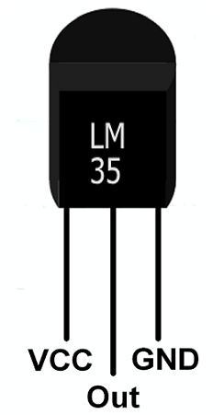

**Fig no.10 LM35 Pins**

* **VCC:**Supply Voltage (4V – 30V)
* **Out:**It gives analog output voltage which is proportional to the temperature (in degree Celsius).
* **GND:**Ground
* 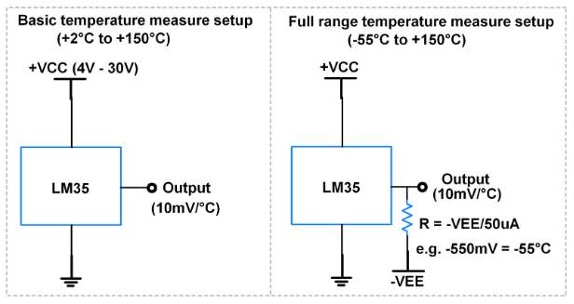**Application Setup**

**Fig no.11 Application setup of LM35**

* **Features**

• Calibrated Directly in Celsius (Centigrade)

• Linear + 10-mV/°C Scale Factor

• 0.5°C Ensured Accuracy (at 25°C)

• Rated for Full −55°C to 150°C Range

• Suitable for Remote Applications

• Low-Cost Due to Wafer-Level Trimming

• Operates From 4 V to 30 V

• Less Than 60-μA Current Drain

• Low Self-Heating, 0.08°C in Still Air

• Non-Linearity Only ±¼°C Typical

• Low-Impedance Output, 0.1 Ω for 1-mA Load

* **Applications**

• Power Supplies

• Battery Management

•HVAC

• Appliances

**3.1.6 ACCELEROMETER**

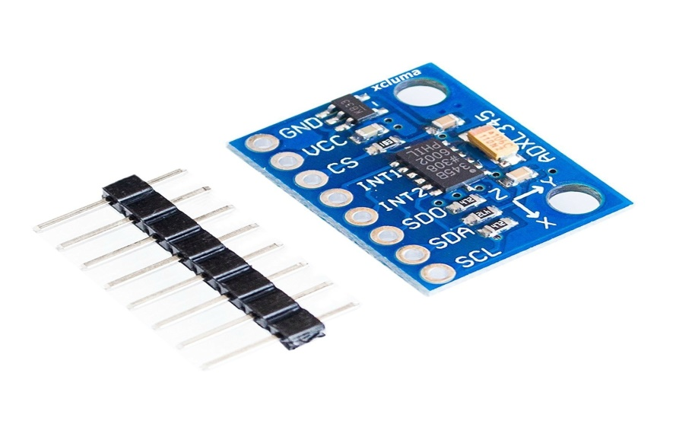

**Fig no.12 Accelerometer**

An accelerometer is a device that measures the vibration, or acceleration of motion of a structure. The force caused by vibration or a change in motion (acceleration) causes the mass to "squeeze" the piezoelectric material which produces an electrical charge that is proportional to the force exerted upon it. Since the charge is proportional to the force, and the mass is a constant, then the charge is also proportional to the acceleration. These sensors are used in a variety of ways from space stations to handheld devices, and there's a good chance you already own a device with an accelerometer in it. For example, almost all smartphones today house an accelerometer. They help the phone know whether it undergoes acceleration in any direction, and it’s the reason why your phone’s display switches on when you flip it. In an industry setting, accelerometers help engineers understand a machine's stability and enable them to monitor for any unwanted forces/vibrations.

* **Working**

An accelerometer works using an electromechanical sensor that is designed to measure either static or dynamic acceleration. Static acceleration is the constant force acting on a body, like gravity or friction. These forces are predictable and uniform to a large extend. For example, the acceleration due to gravity is constant at 9.8m/s, and the gravitation force is almost the same at every point on earth.

Dynamic acceleration forces are non-uniform, and the best example is vibration or shock. A car crash is an excellent example of dynamic acceleration. Here, the acceleration change is sudden when compared to its previous state. The theory behind accelerometers is that they can detect acceleration and convert it into measurable quantities like electrical signals.

* **Types**

There are [two types of piezoelectric accelerometers (vibration sensors)](https://www.omega.com/en-us/resources/accelerometers-types). The first type is a "high impedance" charge output accelerometer. In this type of accelerometer the piezoelectric crystal produces an electrical charge which is connected directly to the measurement instruments. The charge output requires special accommodations and instrumentation most commonly found in research facilities. This type of accelerometer is also used in high temperature applications (>120C) where low impedance models can not be used.

The second type of accelerometer is a low impedance output accelerometer. A low impedance accelerometer has a charge accelerometer as its front end but has a tiny built-in micro-circuit and FET transistor that converts that charge into a low impedance voltage that can easily interface with standard instrumentation. This type of accelerometer is commonly used in industry. An accelerometer power supply like the ACC-PS1, provides the proper power to the microcircuit 18 to 24 V @ 2 mA constant current and removes the DC bias level, they typically produces a zero based output signal up to +/- 5V depending upon the mV/g rating of the accelerometer. All OMEGA(R) accelerometers are this low impedance type.

* **Applications:**

Accelerometers find many applications in industries. As already discussed, you can find them in the most complex machines to your handheld devices. Let’s look at some of the real-world applications of accelerometers.

**Digital Devices:** Accelerometers in smartphones and digital cameras are responsible for rotating the display based on the orientation you hold it.  
  
**Vehicles:** The invention of airbags have saved millions of lives over the years. Accelerometers are used to trigger the airbags as the sensor would send a signal when it experiences a sudden

shock.

**Drones:** Accelerometers help drones to stabilize their orientation midflight.

**Rotating Machinery:** Accelerometers used in rotating machines detect undulating vibrations.

**Industrial Platforms:** To measure platform stability or tilt.

**Vibration Monitoring:** Machines that move generate vibrations, and these vibrations can be harmful to the machines if left to amplify without supervision. Accelerometers are useful in monitoring vibrations and are increasingly used in industrial plants, turbines, etc.

* + 1. **BUZZER**

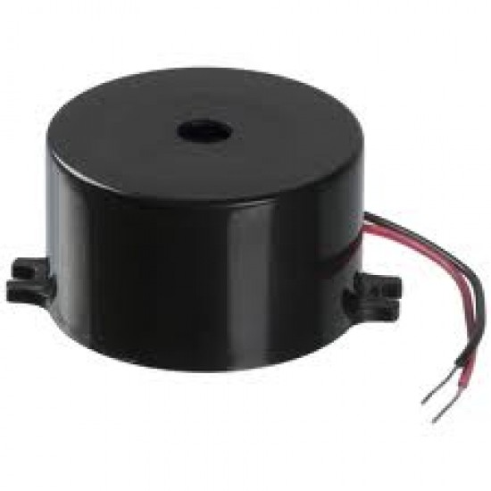

**Fig no.13 Buzzer**

An audio signaling device like a beeper or buzzer may be electromechanical or piezoelectric or mechanical type. The main function of this is to convert the signal from audio to sound. Generally, it is powered through DC voltage and used in timers, alarm devices, printers, alarms, computers, etc. Based on the various designs, it can generate different sounds like alarm, music, bell & siren.

* + 1. **CP2102 USB 2.0 TO TTL UART SERIAL CONVERTER MODULE**

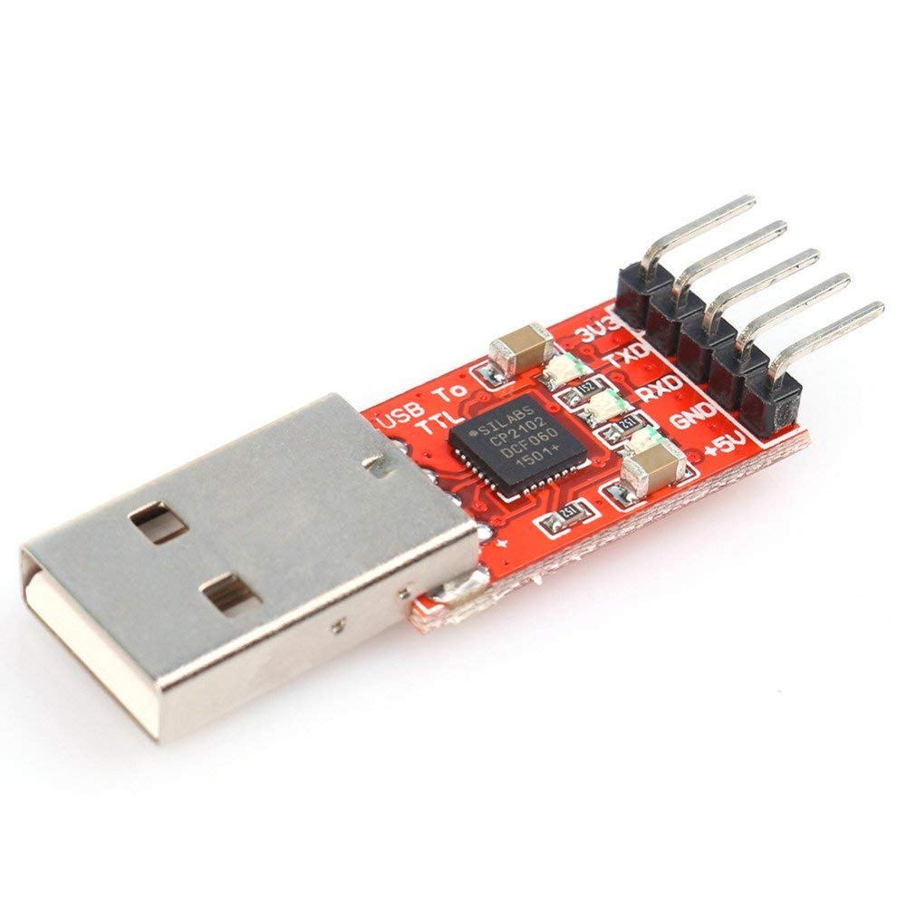

**Fig no.14 CP2102 USB 2.0 to TTL UART serial converter module**

CP2102 chip is a single chip USB to UART bridge IC. It requires minimal external components. CP2102 can be used to migrate legacy serial port based devices to USB. This is the CP2102(6-pin) USB 2.0 to TTL UART serial converter module. This is a great little tool for embedded systems that require a serial connection to a computer. The board can simply attach to a USB bus and will appear as a standard COM port. ThisCP2102 doesn't require any external oscillator, it onboard-board voltage regulator, and it even uses a reprogrammable internal EEPROM for the device description. The full hardware UART has flow control for baud rates from 300bps to 921600bps. This breakout also allows you to connect the TX/RX pins of your favorite microcontroller or serial application to the RX/TX pins of the breakout, creating a simple serial cable replacement.

**Pinouts:-**

* TX = Connect to Transmit Pin(TXD) of Micro controller. This pin is RX pin of CP2102 on board.
* RX = Connect to Receive Pin(RXD) of Micro controller. This pin is TX pin of CP2102 on board.
* RST = Normally Unconnected. Reset Pin for CP2102. Initiate a system reset by driving this pin low for atleast 15 µs.
* GND = Should be common to microcontroller ground.
* 3V3 = Optional output to power external circuit upto 50mA.
* 5V = Optional output to power external circuit upto 100mA
* **Features:-**
* Stable and reliable chipset CP2102.
* USB specification 2.0 compliant with full-speed 12Mbps.
* Standard USB type A male and TTL 6pin connector.
* 6pins for 3.3V, RST, TXD, RXD, GND & 5V.
* Baud rates: 300 bps to 1.5 Mbps
* Byte receive buffer; 640 byte transmit buffer.
* Hardware or X-On/X-Off handshaking supported.
* Event character support Line break transmission.
* USB suspend states supported via SUSPEND pins.
* Temperature Range: -40 to +85.
* Size: 42mm X 15mm.
* Weight: 4g

##### **Supported operating systems**

* Windows 98/Me/2000/7
* MAC OS-9
* MAC OS
* X-Windows CE
* Linux 2.40 or later

**3.2 ARCHITECTURE OF PROPOSED SYSTEM**

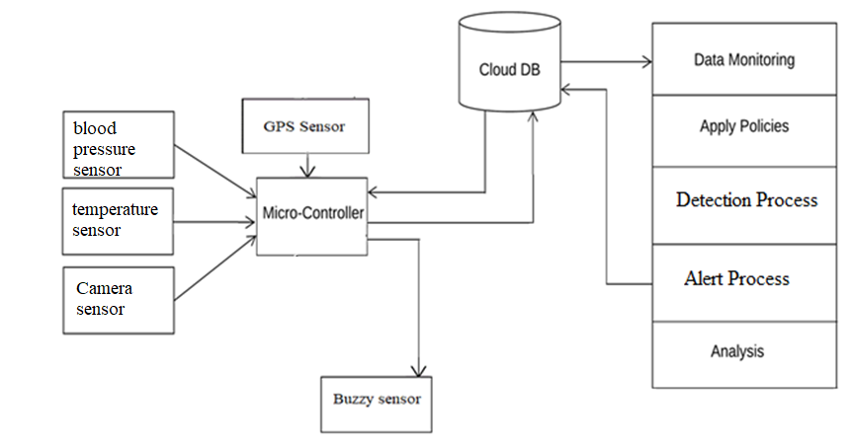

**Fig no.15 Architecture of proposed system**

* Two phases:: training and testing.
* 1) Training::
* Collect IOT environment data.
* Apply data mining approaches.
* Data is been saved into the database called as background knowledge, which is used at the time of testing.
* 2) Testing::
* The system produces the IoT-based healthcare system environment
* All collected data is stored into global database using connection oriented architecture.
* In testing we read all testing as well as training data simultaneously.
* Apply detection the possible using decision making system.
* Using IOT technology we can continuously monitor changes in sensors values.
* GPS + GSM module is connected to arduino UNO, this two Module collects the information and sends data to Arduino Uno.
* Buzzer is an audio signal device, which is used to buzz sound whenever it is needed.
* At last, a sms(short message service) or mail is sends to a phone.

**3.3 WORKING**

In the Architecture of proposed system components like GPS Sensor , Blood pressure sensor , Temperature Sensor , Buzzer , Camera are connected to the microcontroller. Cloud Data based is also connected to microcontroller which perform the following task :

1) Data monitoring

2) Apply policies

3) Detection process

4) Alert process

5) Analysis

GPS + GSM module is connected to arduino UNO, this two Module collects the information and sends data to Arduino Uno.

* WORKING OF THE PROPOSED SYSTEM

Women safety device is IOT based project. We are supplying 5V to each component connected to Arduino like Buzzer , accelerometer , GPS module , Temperature Sensor , except BP sensor. Because BP monitor needs voltage supply more than 5V but Arduino doesn't take supply more than 5V so we are using USB cable (CP2102 USB 2.0 to TTL UART serial converter module) to avoid damage to Arduino. Here we are using Accelerometer to measure the direction of the user . An accelerometer is a device that measures the vibration, or acceleration of motion of a structure. Buzzer is an audio signal device, which is used to buzz sound whenever it is needed.

The buzzer goes on when the Accelerometer goes in the direction except than above mentioned X,Y,Z acces in which accelerometer works.

We have set the temperature of temperature sensor to 28 degree celcius in the code if the temperature of the user body exceed beyond the limit buzzer turns on and the message will be send to the register gurdian .The basic principle of working of the temperature sensors is the voltage across the diode terminals. If the voltage increases, the temperature also rises.

The system provides the functionality of the BP monitoring were we have set the limit for BP if it exceeds the limit the message will send to register gurdian of the user. We get three values as

OUTPUT on SUNROM BP SENSOR:

1) Systolic

2) Diastolic

3) Pulse per minute

Blood Pressure Levels :

• Normal = systolic: less than 120 mm Hg & diastolic: less than 80 mm Hg

• At Risk (prehypertension) = systolic: 120–139 mm Hg diastolic: 80–89 mm Hg

• High Blood Pressure (hypertension) : systolic: 140 mm Hg or higher diastolic: 90 mm Hg or higher

GPS receivers are generally used in smartphones, fleet management system, military etc. for tracking or finding location. In our project GPS is used to track the location of user , the location is track by the longitude and latitude on Google map . Both longitude and latitude are angles measured with the center of the earth as an origin.

We are using camera IP Pro app interface with IP address code. Camera sensor is used to capturing the images when the user is in trouble and images are send to gurdian through Gmail . The image is in the PNG format , it takes one minute to send gurdian All the data is gathered at cloud data based and through which it performs the process like:

1) Data monitoring

2) Apply policies

3) Detection process

4) Alert process

5) Analysis

The code has been written into python language in which we are set limit for BP sensor , Temperature Sensor, Accelerometer and is transferred to Arduino via cable . The output code message will be sent to the gurdian .

## 3.4 Special Features

## 

## DUAL ALERT 2. GPS TRACKER

## 

## WEB CAMERA 4. HEART MONITORING

## 

## TEMPERATURE 6. MESSAGE

## 4. CODE SOURCE & RESULT

* **CODE SOURCE**

import time

import smtplib

from email.mime.multipart import MIMEMultipart

from email.mime.text import MIMEText

from email.mime.base import MIMEBase

from email import encoders

import imaplib

#import pymysql as mdb

import serial

port = serial.Serial("COM6", baudrate=9600, timeout=1)

port1 = serial.Serial("COM7", baudrate=9600, timeout=1)

def mails(cc):

print('kk')

fromaddr = "sur5gk@gmail.com"

password='dgrb obcg nqjn ntwt'

toaddr = 'harshali.06borhade@gmail.com'

msg = MIMEMultipart()

msg['From'] = fromaddr

msg['To'] = 'harshali.06borhade@gmail.com'

# storing the subject

msg['Subject'] = "Emergency please chk photo"

# string to store the body of the mail

body = cc

msg.attach(MIMEText(body, 'plain'))

filename='1.png'

filename = filename

attachment = open(filename, "rb")

p = MIMEBase('application', 'octet-stream')

p.set_payload((attachment).read())

encoders.encode_base64(p)

p.add_header('Content-Disposition', "attachment; filename= %s" % filename)

# attach the instance 'p' to instance 'msg'

msg.attach(p)

# creates SMTP session

s = smtplib.SMTP('smtp.gmail.com', 587)

# start TLS for security

s.starttls()

# Authentication

s.login(fromaddr, password)

# Converts the Multipart msg into a string

text = msg.as_string()

# sending the mail

s.sendmail(fromaddr, toaddr, text)

print('email done')

def cap():

import cv2

print('here')

video = cv2.VideoCapture('http://192.168.1.103:8080/video')

print('here')

check, frame = video.read()

frame=cv2.resize(frame, (780, 540))

print(check)

cv2.imwrite("1.png",frame)

video.release()

print('capture image')

#mails('')

while True:

valu=port.readline().decode()

#print (valu)

if valu!="":

try:

x,lat,lon,temp=valu.split(',')

print ("temperature",temp,"Latitude",lat,"longitude",lon,"x",x)

temp=float(temp)

x=float(x)

if temp>24 or x<6:

print('sending email')

print('here')

cap()

mails(lat+'----'+lon)

except Exception as e:

print(e)

val=port1.readline().decode()

#print (valu)

if val!="":

try:

sys,dia,pr=val.split(',')

print ("Systolic",sys,"Diastolic",dia,"Pulserate",pr)

except:

print('r')

* **RESULT**

These are the outputs which are observed for our project while under working.

**BEFORE EXECUTION:**

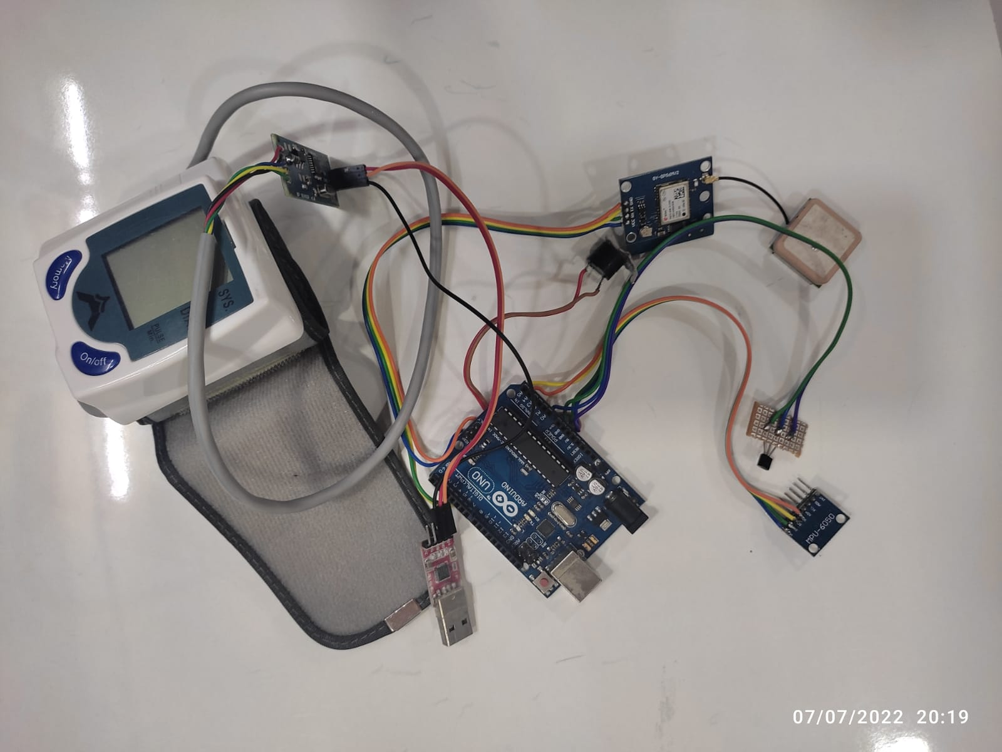

**AFTER EXECUTION:** 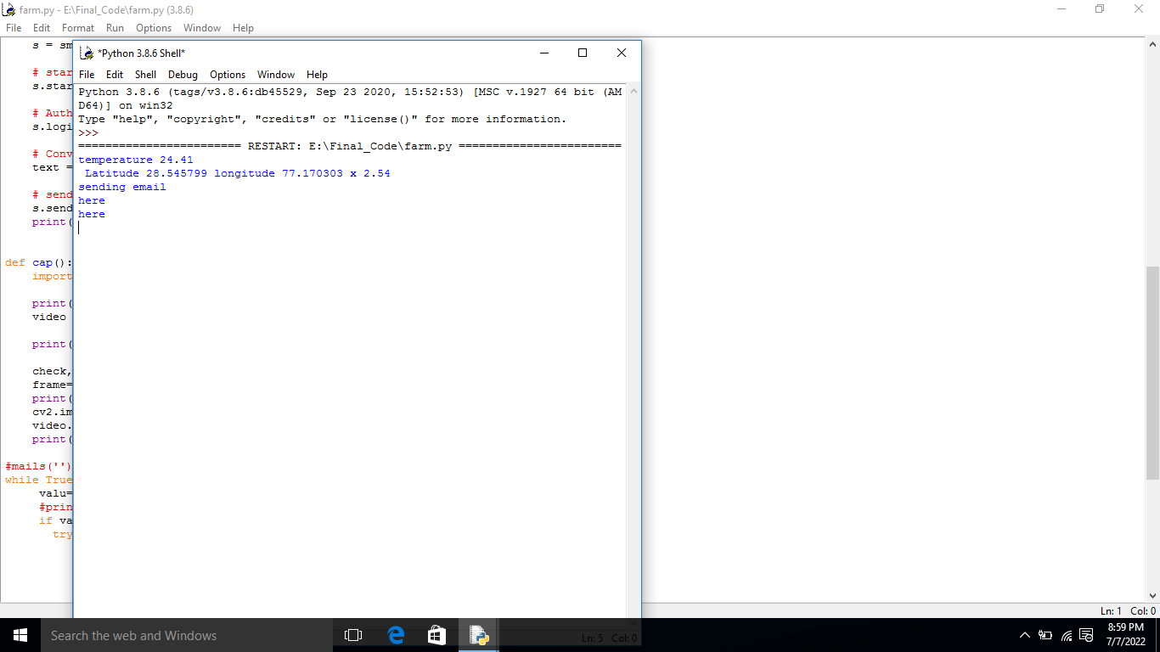

**Result on Laptop after connecting USB**

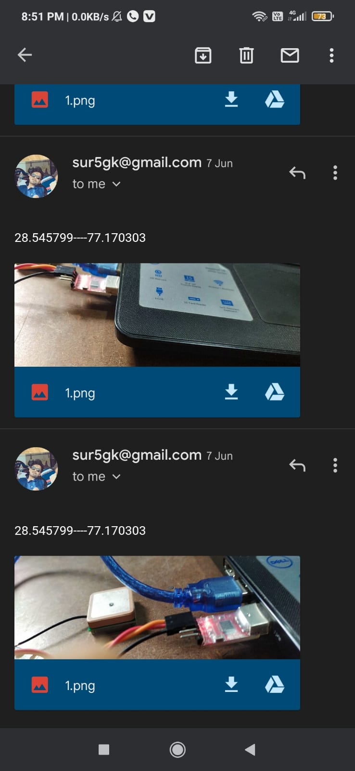

**Image sent on mail**

# CONCLUSION

## CONCLUSION

* Our effort behind this project is to design and fabricate a gadget which is so compact in itself that provide advantage of personal security system the emergency response system which is helpful for women in the incidents of crime.
* It is low cost system which can store the data of the members in the particular locality and provide immediate alert in case of crime against women.
* This provides women security. Being safe and secure is the demand of the day.
* The vast growth of information technology leads to the invention of many IOT based devices and application are available to ensure the security of women in the society by providing automatic sensing of threats and automated messages to the relatives or to the police station.
  1. **FUTURE SCOPE**

1) We can interface this system with smart phones , mobiles and laptop.

2) we can use this safety device with bags , luggage , vehicles , belt , etc.

3) By using Nano size material we can reduce the kit size

4) This system we are also use in vehicles airs bags that can detect the measure accidents

5) We can place this module in the smart watches

6) We can add the Bluetooth message option for Rural Areas

* 1. **APPLICATION**

1) It is use for Safety for women.

2) It will be use for child tracking during school time , playing time etc .

3) The system module is also use for vehicle air bags to avoid measure accidents.

## ADVANTAGES AND DISADVANTAGES

* + 1. **Advantages**
* Simple, small & inexpensive
* Uses commonly available components
* It is safe and easy to use.
* It can be used by children, teenager girls, women, old lady Or old men.
* Sophisticated security.

• Monitors all hazards and threats.

• Alert mail with image to mobile phone for remote information.

• Gmail can be changed at any time.

• Can be used to prevent incidents.

## Disadvantages

* Non wearable device.
* The IP WEB CAMERA APP should be ON then the photos are taken at the place of incident and sent to the mail.

## REFERENCES

[1] Ghosh, Prottasha, et al. "Smart Security Device for Women Based on IoT Using Raspberry Pi." 2021 2nd International Conference on Robotics, Electrical and Signal Processing Techniques (ICREST). IEEE, 2021.

[2] Hyndavi, V., N. Sai Nikhita, and S. Rakesh. "Smart wearable device for women safety using IoT." 2020 5th International Conference on Communication and Electronics Systems (ICCES). IEEE, 2020.

[3] Kabir, AZM Tahmidul, and Tasnuva Tasneem. "Safety Solution for Women Using Smart Band and CWS App." 2020 17th International Conference on Electrical Engineering/Electronics, Computer, Telecommunications and Information Technology (ECTI-CON). IEEE, 2020.

[4] Akram, Wasim, Mohit Jain, and C. Sweetlin Hemalatha. "Design of a smart safety device for women using IoT." Procedia Computer Science 165 (2019): 656-662.

[5] Sunehra, Dhiraj, et al. "Raspberry Pi Based Smart Wearable Device for Women Safety using GPS and GSM Technology." 2020 IEEE International Conference for Innovation in Technology (INOCON). IEEE, 2020.